Mathematics Specialist
Unit 3

Test 1

Student name: _______________________

Time allowed for this task: 55 minutes, in class, under test conditions
Section One – calculator-free section – 35 minutes (30 marks)
Section Two – calculator-assumed section – 20 minutes (20 marks)

Materials required: Calculator with CAS capability (to be provided by the student)

Standard items: Pens (blue/black preferred), pencils (including coloured), sharpener, correction fluid/tape, eraser, ruler, highlights

Special items: Drawing instruments, templates, notes on two unfolded sheets of
A4 paper, and up to three calculators approved for use in
WACE examinations

Marks available: 50 marks

Section One – calculator-free section (30 marks)

Question 1 (8 marks)

(a) (2 marks)

(b) (4 marks)
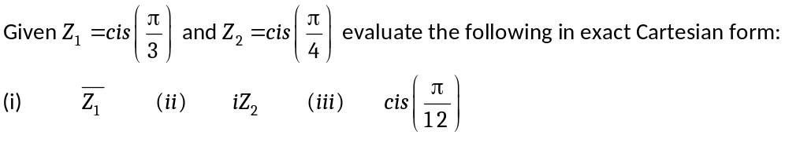

(c) (2 marks)

Question 2 (6 marks)
- .

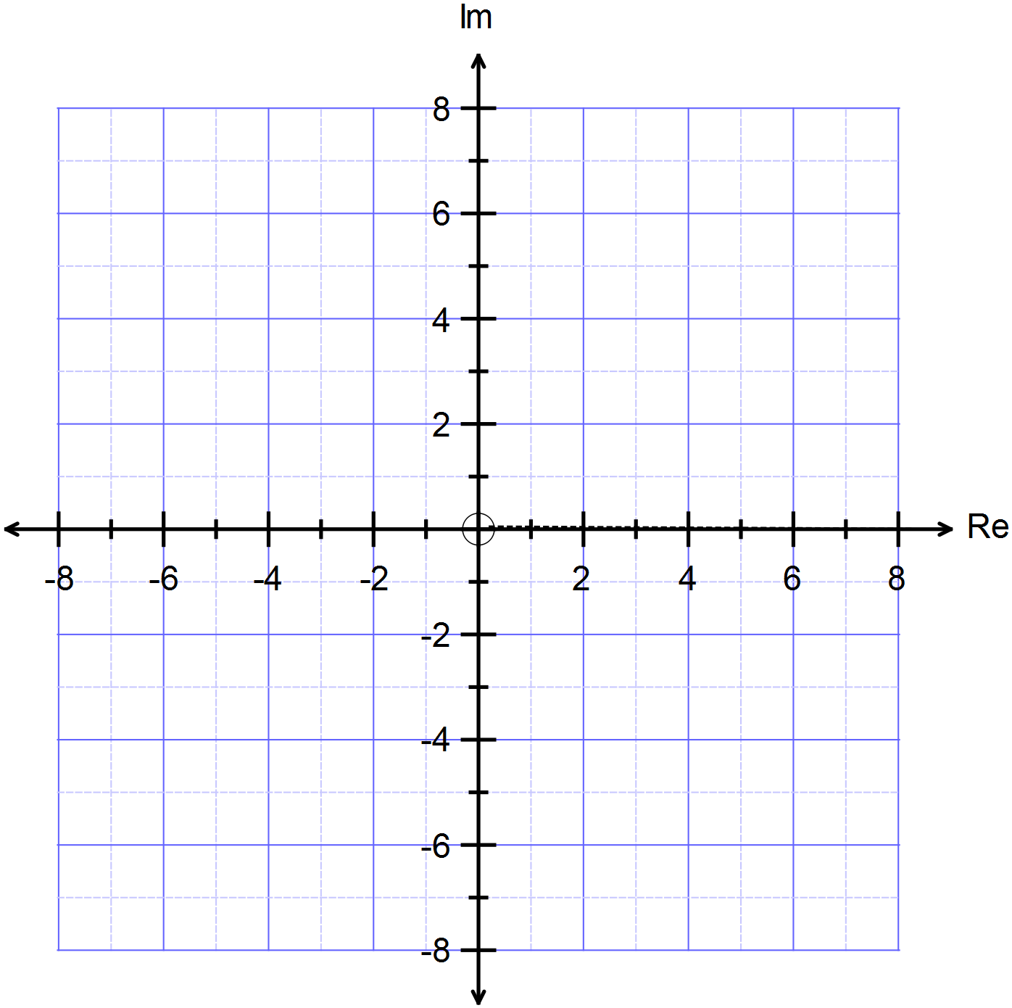

Question 3 (8 marks)

Determine and locate all solutions in the Argand plane to the equation 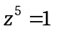.

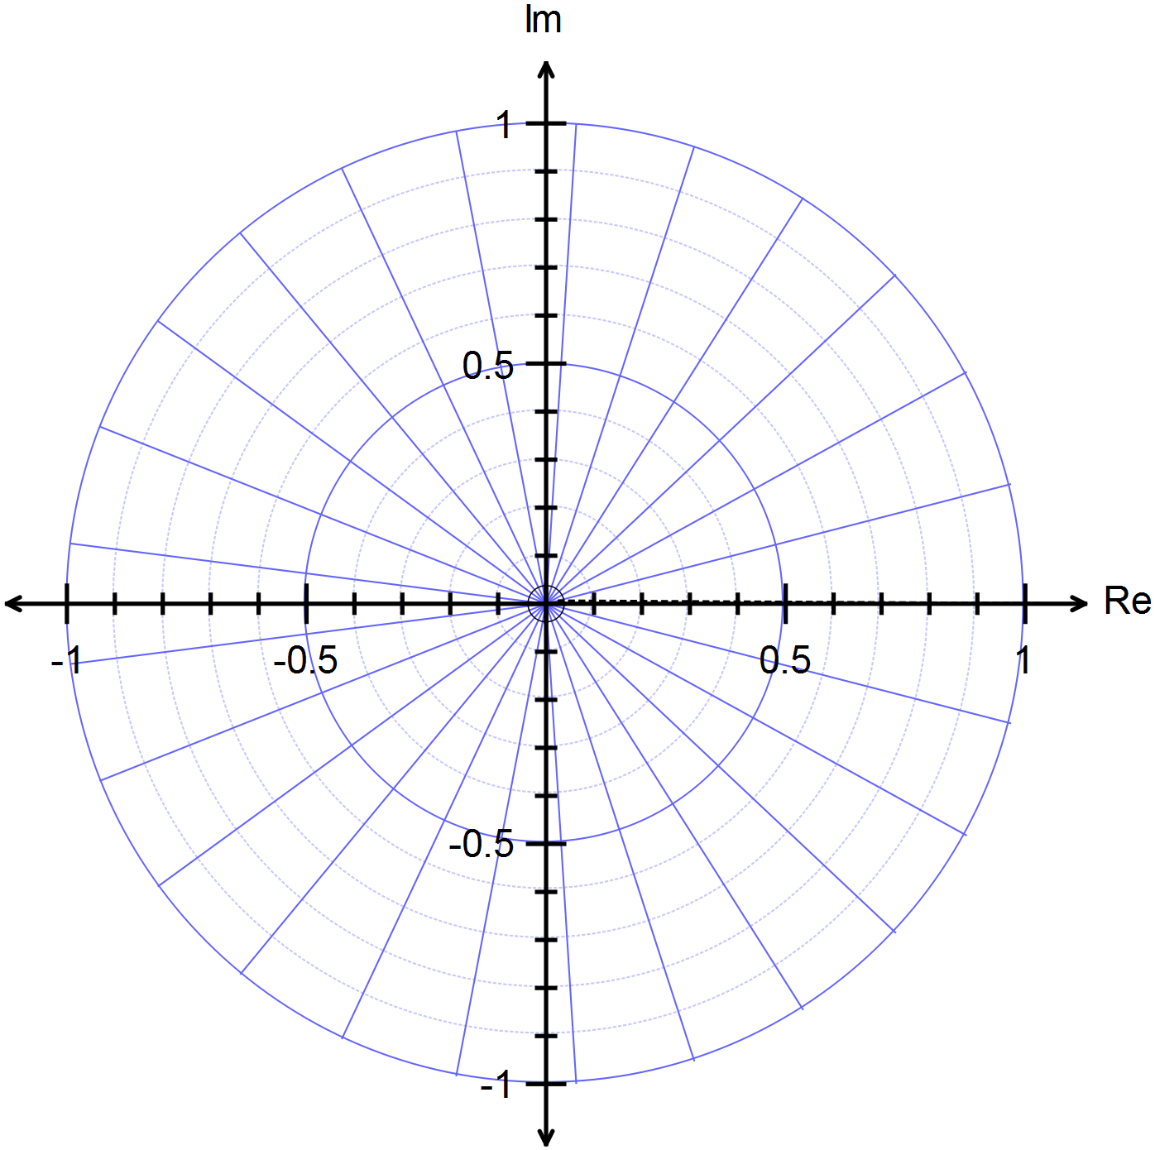
Question 4 (8 marks)

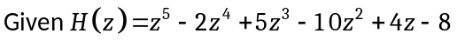

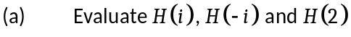. (3 marks)

. (5 marks)

Section Two – calculator-assumed section (20 marks)

Question 5 (10 marks)
- Expand and simplify the expression 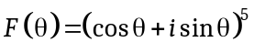. (2 marks)

- (3 marks)

- Use 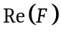to solve the equation 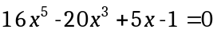and express the solutions in trigonometric form. (5 marks)

Question 6 (3.1.7) (10 marks)
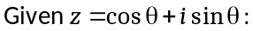

(a) 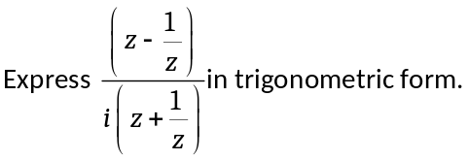 (4 marks)

(b) 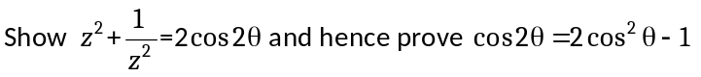. (6 marks)

Solutions and marking key for Test 1

Section One – calculator-free section (30 marks)

Question 1 (3.1.6, 3.1.15) (8 marks)

(a) (2 marks)

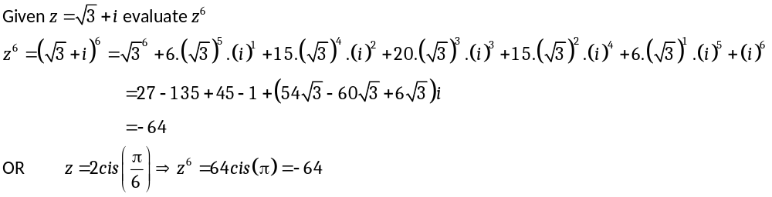
Specific behaviours | Mark | Item
Expands the Cartesian form of z⁶  Simplifies correctly | 1  1 | simple  simple
Or  Expresses z⁶ in polar form  Expresses the answer in Cartesian form | 1  1 | simple  simple

- (4 marks)
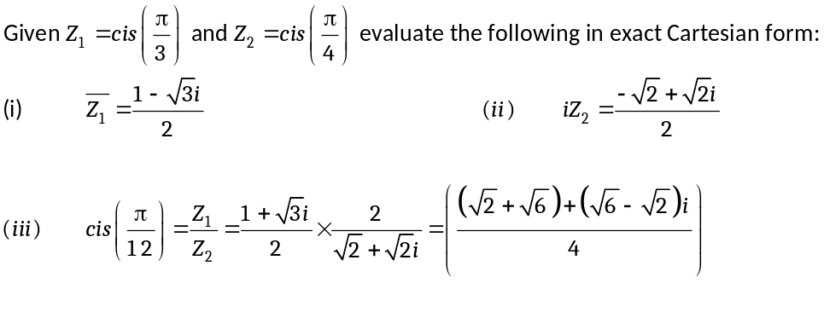
Specific behaviours | Mark | Item
Writes the Cartesian form of 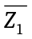 correctly  Writes the Cartesian form of 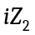 correctly  Expresses polar term for 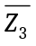 in Cartesian form  Simplifies the Cartesian form correctly | 1  1  1  1 | simple  simple  complex  complex
(c) (2 marks)

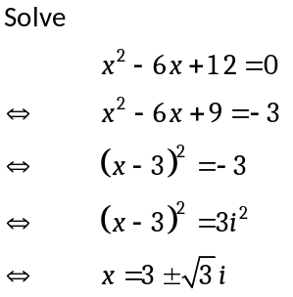 | Or  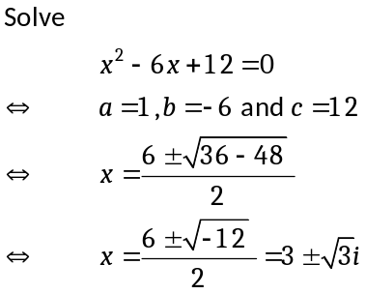
Specific behaviours |  | Mark | Item
Completes the square correctly  Solves the equation using the exact form  Or  Uses the quadratic formula  Simplifies the expressions to the correct exact form |  | 1  1  1  1 | simple  simple  simple  simple

Question 2 (1.1.7) (6 marks)

(a) .

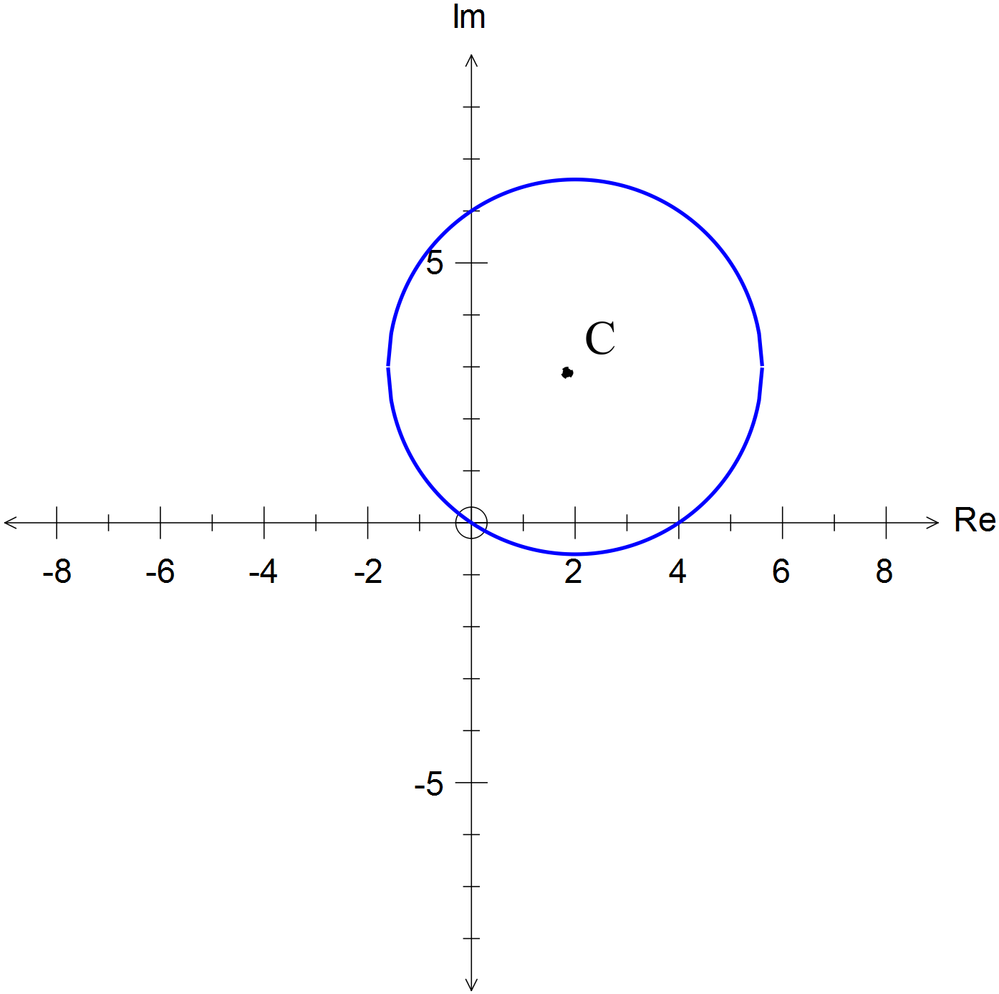
Specific behaviours | Mark | Item
Draws a circle  Has the correct centre (2 + 3i)  Has the correct radius  Circumference passes through (0, 0) (4 + 0i) and (0 + 6i) | 1  1  1  3 | simple  simple  simple  simple

Question 3 (3.1.11, 3.1.12) (8 marks)
Determine and locate all solutions in the Argand plane to the equation .

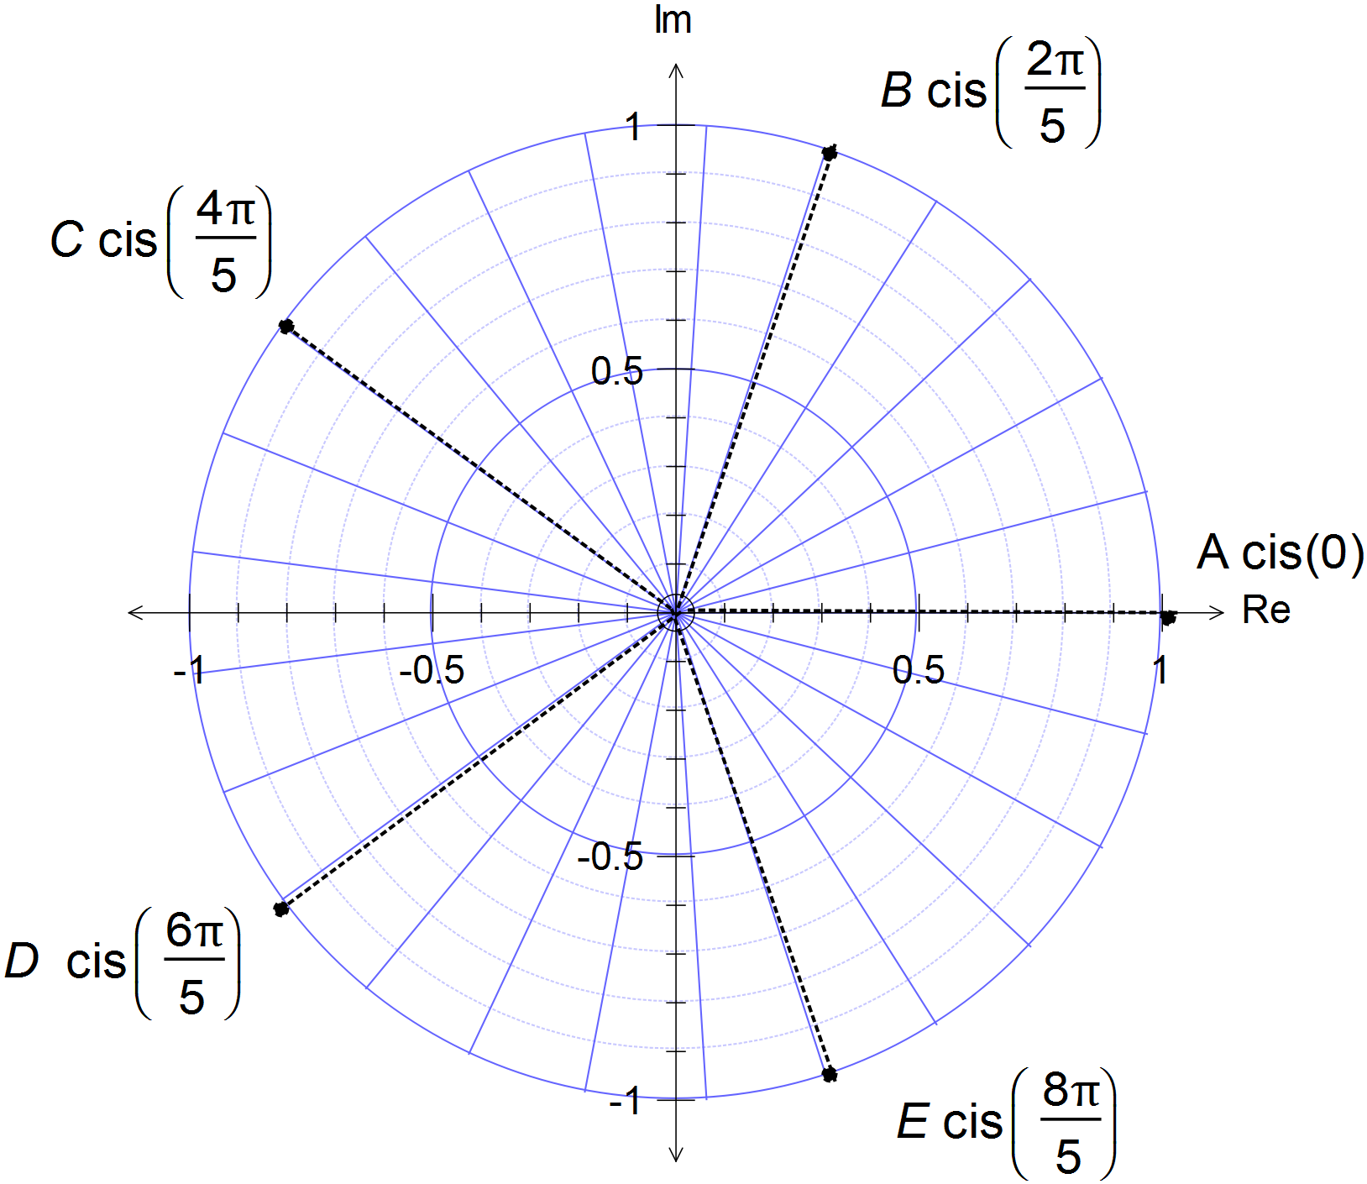 |  | 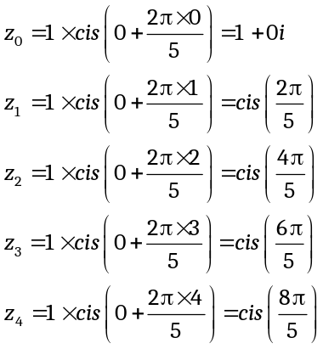
Specific behaviours |  |  | Mark | Item
Expresses the five solutions correctly  Locates the solutions accurately on a polar graph |  |  | 5  3 | simple  simple

Question 4 (3.1.13, 3.1.15) (8 marks)
:
(3 marks)
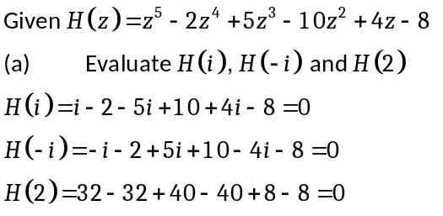
Specific behaviours | Mark | Item
Evaluates each of the three terms 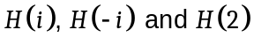 | 3 | simple
(5 marks)
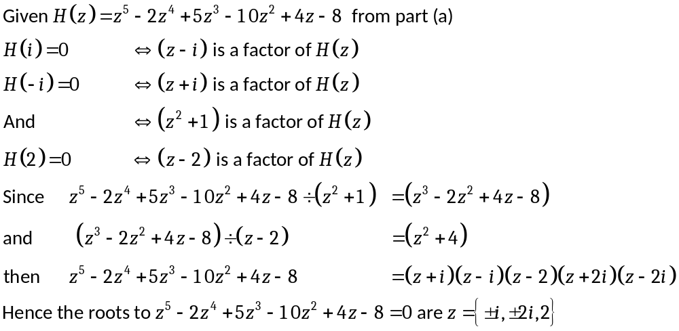

Specific behaviours | Mark | Item
Uses the factor theorem to give factors 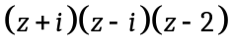  Determines the remaining factors 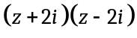  Correctly writes all the roots | 1  2  2 | simple  complex  complex
Section Two – calculator-assumed section (20 marks)

Question 5 (3.1.7) (10 marks)

- Expand and simplify the expression 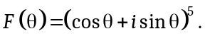 (2 marks)

Specific behaviours | Mark | Item
Shows the real and imaginary terms correctly | 2 | simple

- (3 marks)
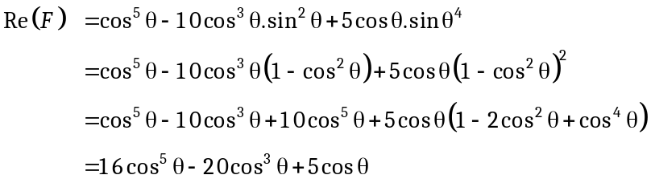
Specific behaviours | Mark | Item
Writes the real part of 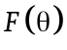  Substitutes for 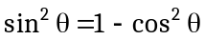  Gives the correct expression for | 1  1  1 | simple  simple  simple

- Use and express the solutions in trigonometric form. (5 marks)

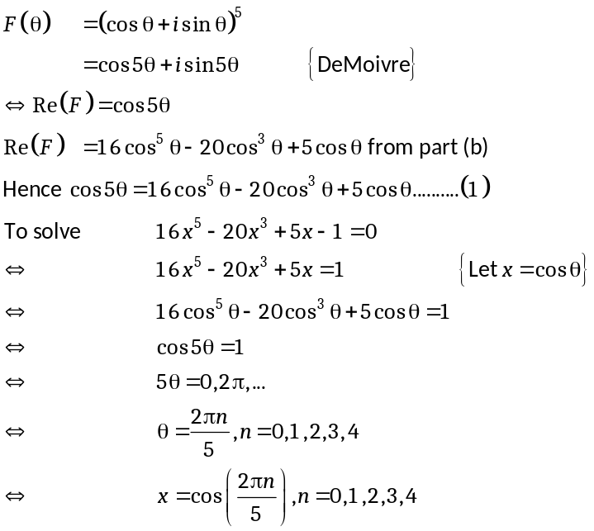
Specific behaviours | Mark | Item
Uses De Moivre to state 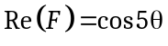  Makes the substitution 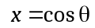in polynomial  Replaces the polynomial in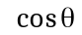 with 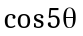  Solves 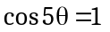in terms of  Gives all five solutions in terms of x | 1  1  1  1  1 | complex  complex  complex  complex  complex

Question 6 (3.1.7) (10 marks)
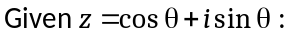
- (4 marks)
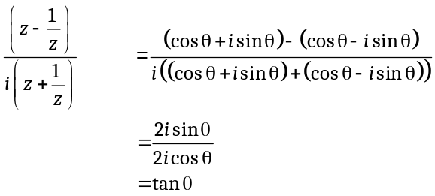
Specific behaviours | Mark | Item
Rewrites the complex numbers 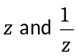 in trig form  Simplifies both numerator and denominator  Writes the correct final term | 2  2 | simple  simple

(b) 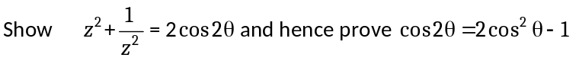 (6 marks)

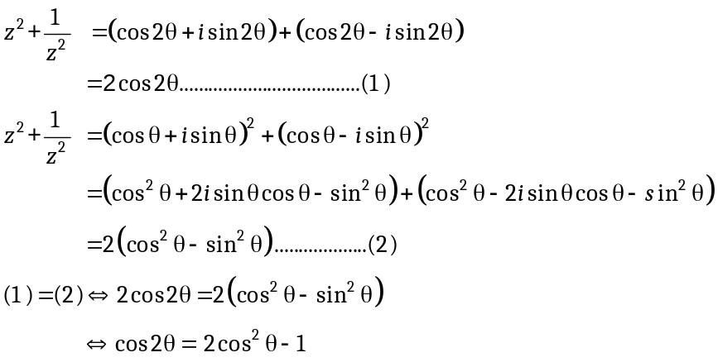
Specific behaviours | Mark | Item
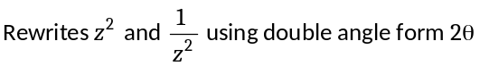  Gathers terms and simplifies  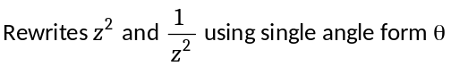  Gathers terms and simplifies  Equates both equations  Writes correct final expression | 1  1  1  1  1  1 | complex  complex  complex  complex  complex  complex

Question | 1 | 2 | 3 | 4 | 5 | 6 | Total
Simple | 8 | 6 | 8 | 4 | 5 | 4 | 35
Complex | 0 | 0 | 0 | 4 | 5 | 6 | 15
 | 8 | 6 | 8 | 8 | 10 | 10 | 50

